Task1:

* After add the ‘nameserver 10.0.2.8’ entry to the ‘/etc/resolvconf/resolv.conf.d/head’ file of the user machine then applied the command ‘ sudo resolvconf -u’. When I run command ‘dig www.google.com’, I got the result which indicate the server as 10.0.2.8 which is my local DNS server.
* Result:

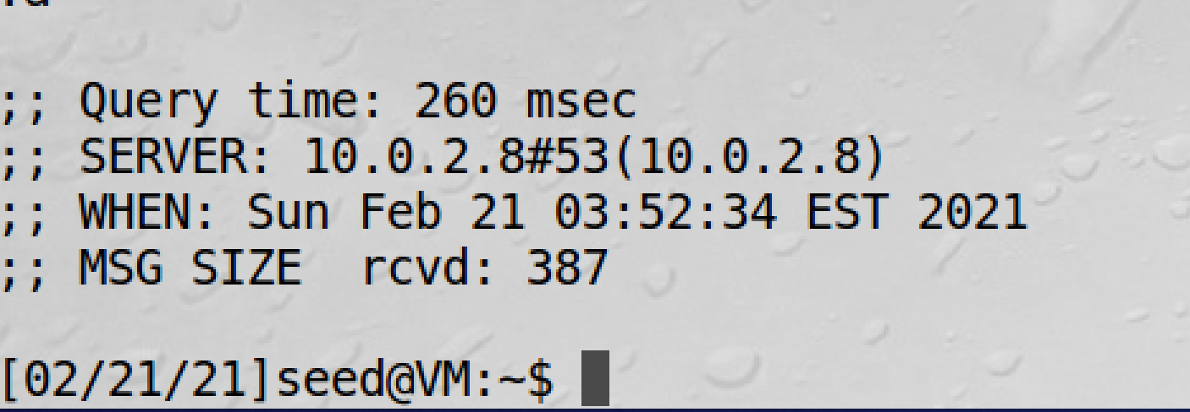

Task2:

* Based on the instruction, I set up a forward zone on the /etc/bind/named.conf file of the local DNS server machine. Under this condition, the local DNS server will not try to find IP address of the shangzewen.com’s nameserver, it will just go to the attacker’s ip address which is ’10.0.2.9’. The remaining set up is already been done in the seed lab vm. After all the set up, I use command ‘sudo service bind9 restart’ to restart the DNS server.

Code:

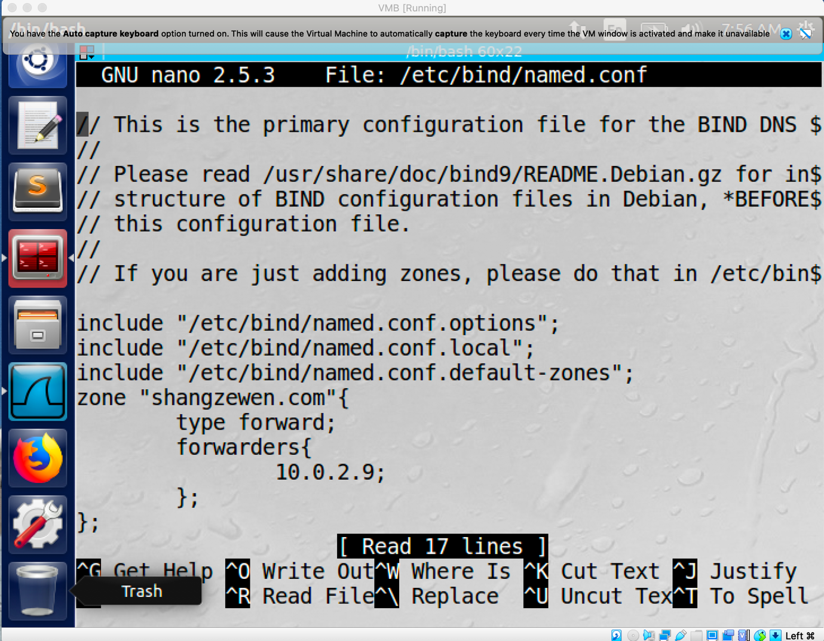

Task3:

* After I download the attacker32.com.zone and example.com.zone, I modified them and move both of them to the ‘/etc/bind’ directory. I change the all the entries of the attacker32.com.zone and ns entry of example.com.zone to the attacker’s IP address which is ‘10.0.2.9’ and change the .zone file name of attacker32.com to shangzewen.com.zone. Then I add following entries to the ‘/etc/bind/named.conf’ file.

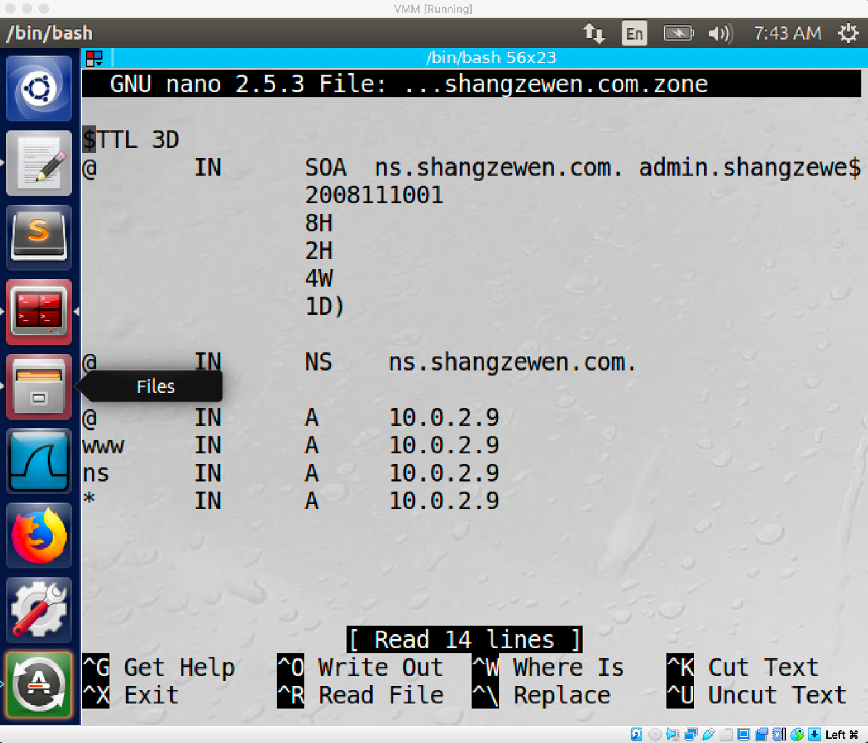

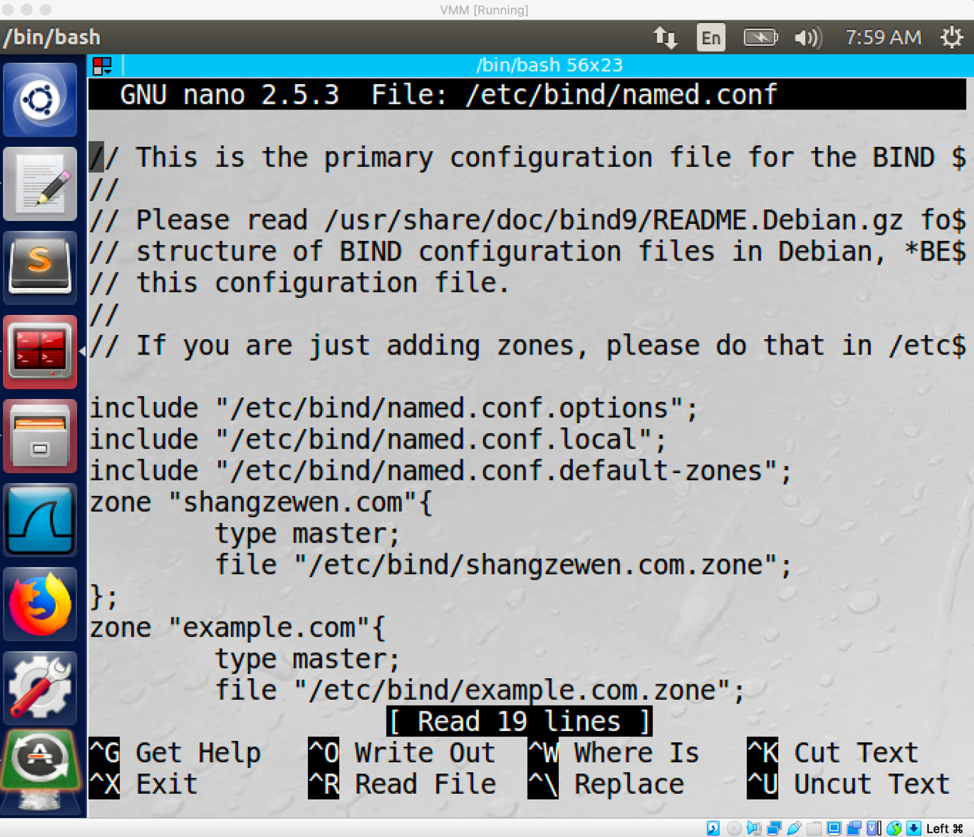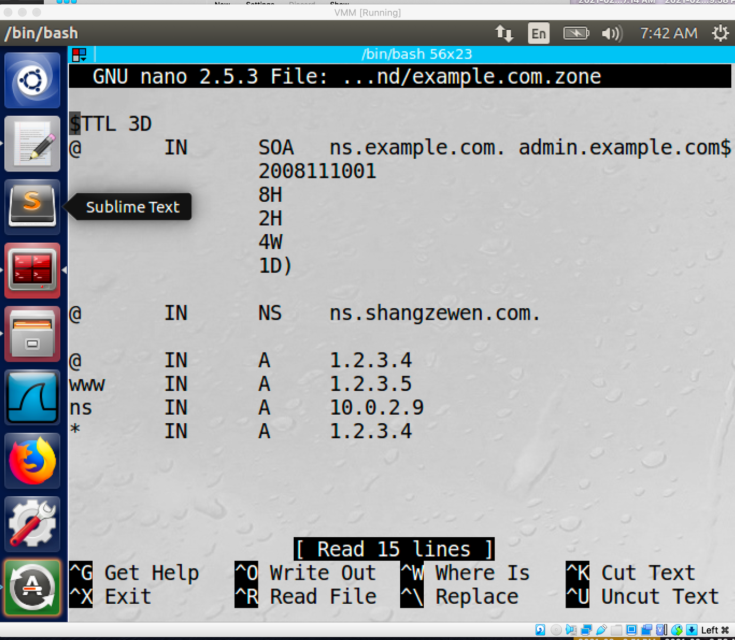

Task4:

* After I run the command ‘ dig ns.shangzewen.com’ , the ip address of the ‘ns.shangzewen.com’ become 10.0.2.9 since we set up the ns entry of the ‘shangzewen.com.zone’ to 10.0.2.9.
* Result:

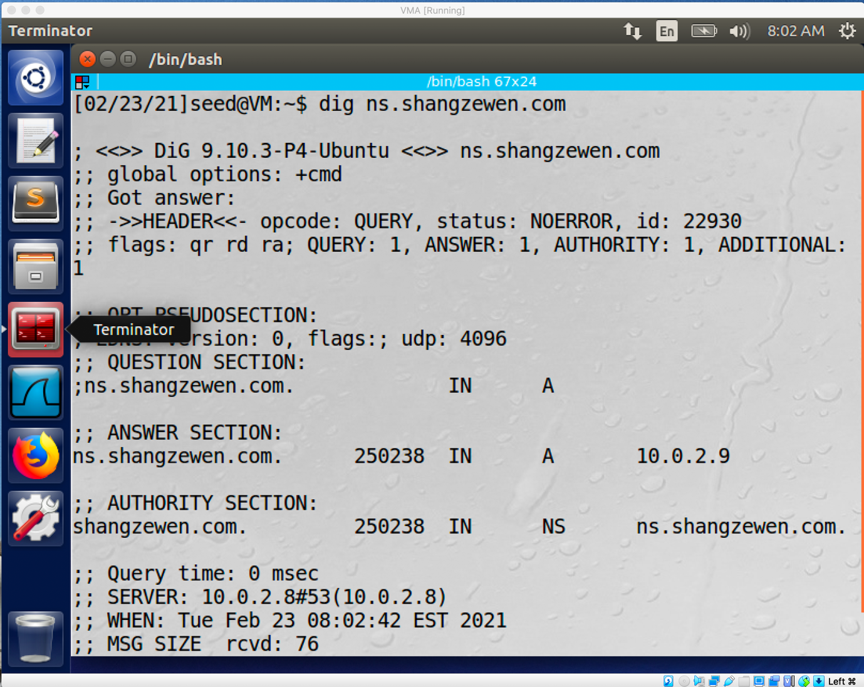

* If I direct run command ‘dig [www.example.com](http://www.example.com)’ , the Ip address of this nameserver will be its real ip address which is 93.184.216.34.

Result:

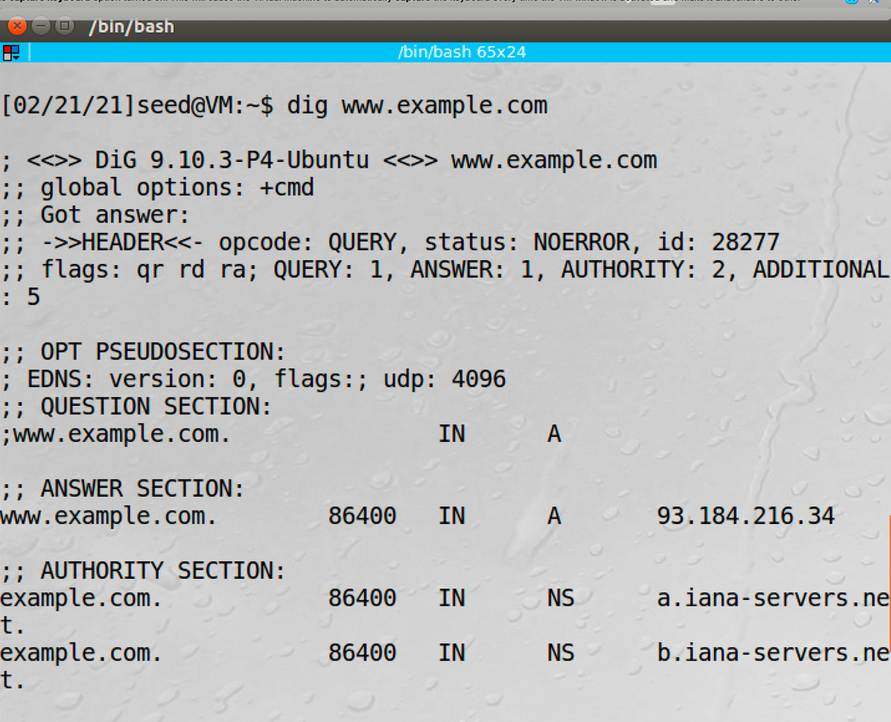

* If I run command ‘ dig @ns.shangzewen.com [www.example.com](http://www.example.com)’ instead, I will get the www entry of the ‘example.com.zone’ which is 1.2.3.5 and it get it form the ‘ns.shangzewen.com’.

Result:

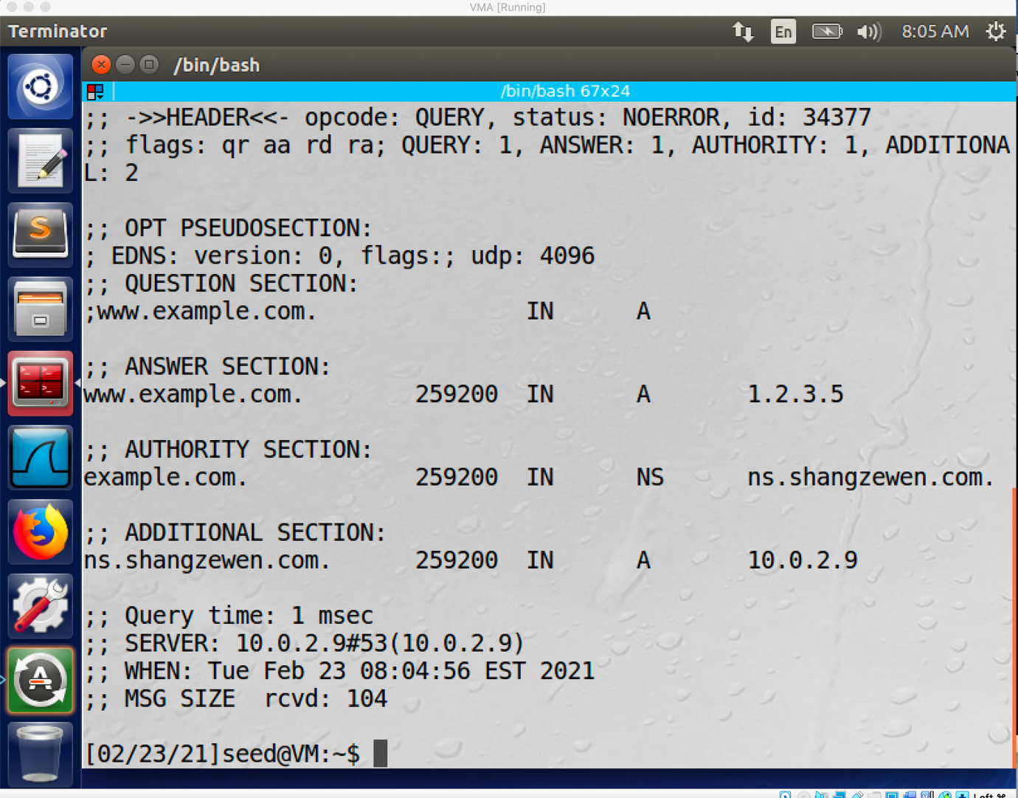

Task4:

* Code:

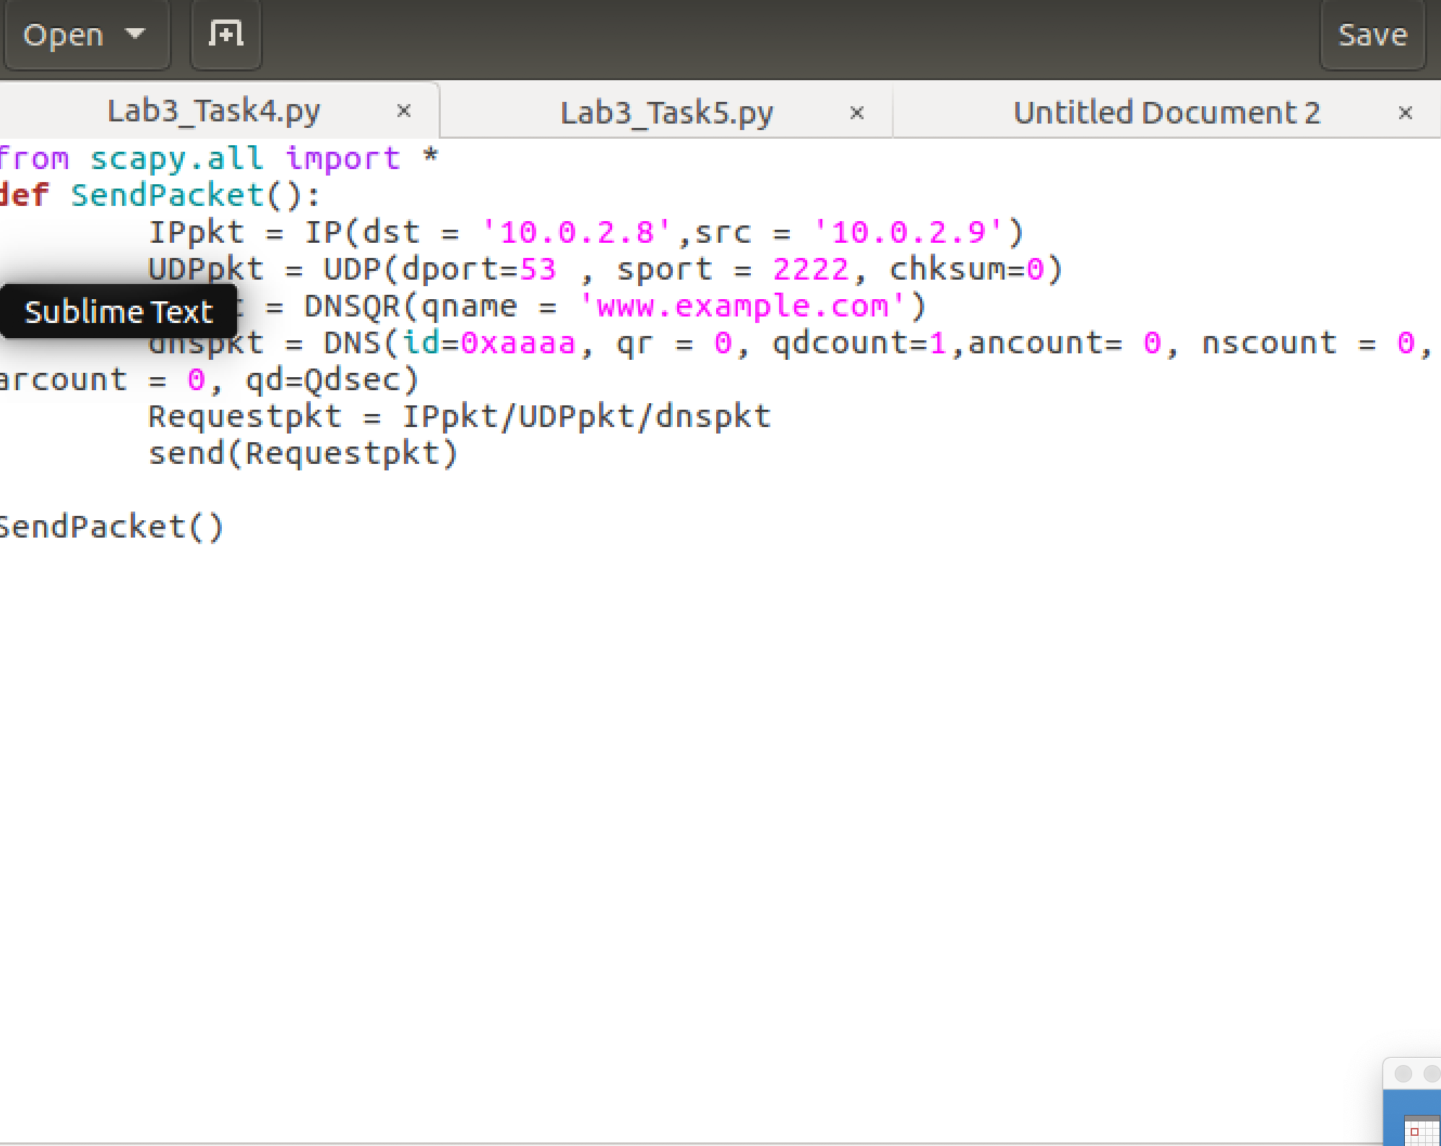

The src IP will be the attacker’s IP and the dst IP will be the DNS server’s IP.

* Result:



The packet will show port unreachable since the DNS request is fake.

Task5:

* Code:

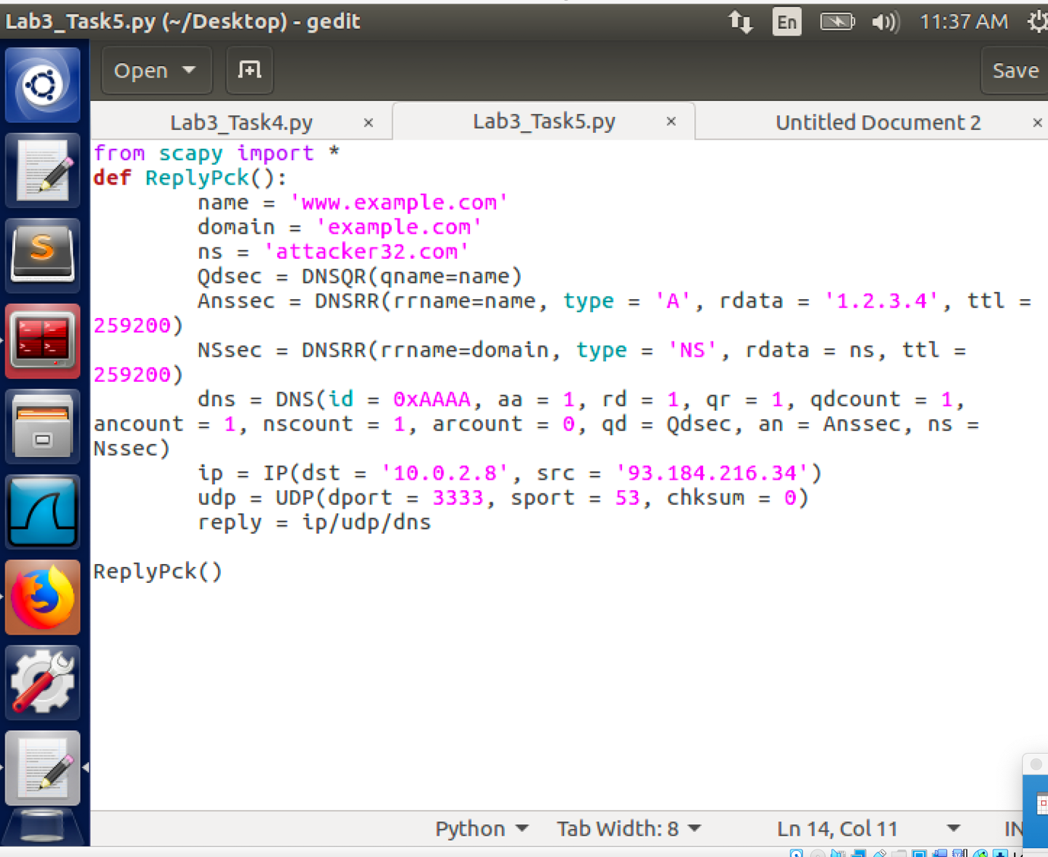

The src IP will be the real IP of the ‘www.example.com’ and the dst IP will be the local DNS server’s IP.

* Result:

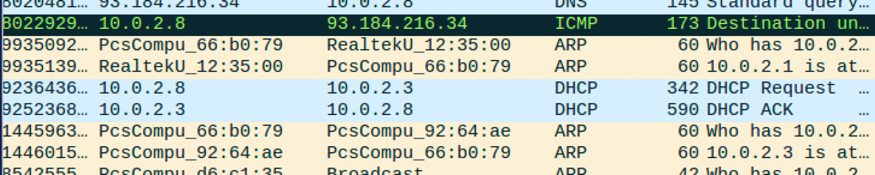

The packet will show port unreachable since the DNS reply is fake.

Task6:

* First of all, I will use scapy library of python to generate the DNS request and response file and include them in ‘iq_req.bin’ and ‘iq_reps.bin’ file which will called by attack.c file.
* Code:

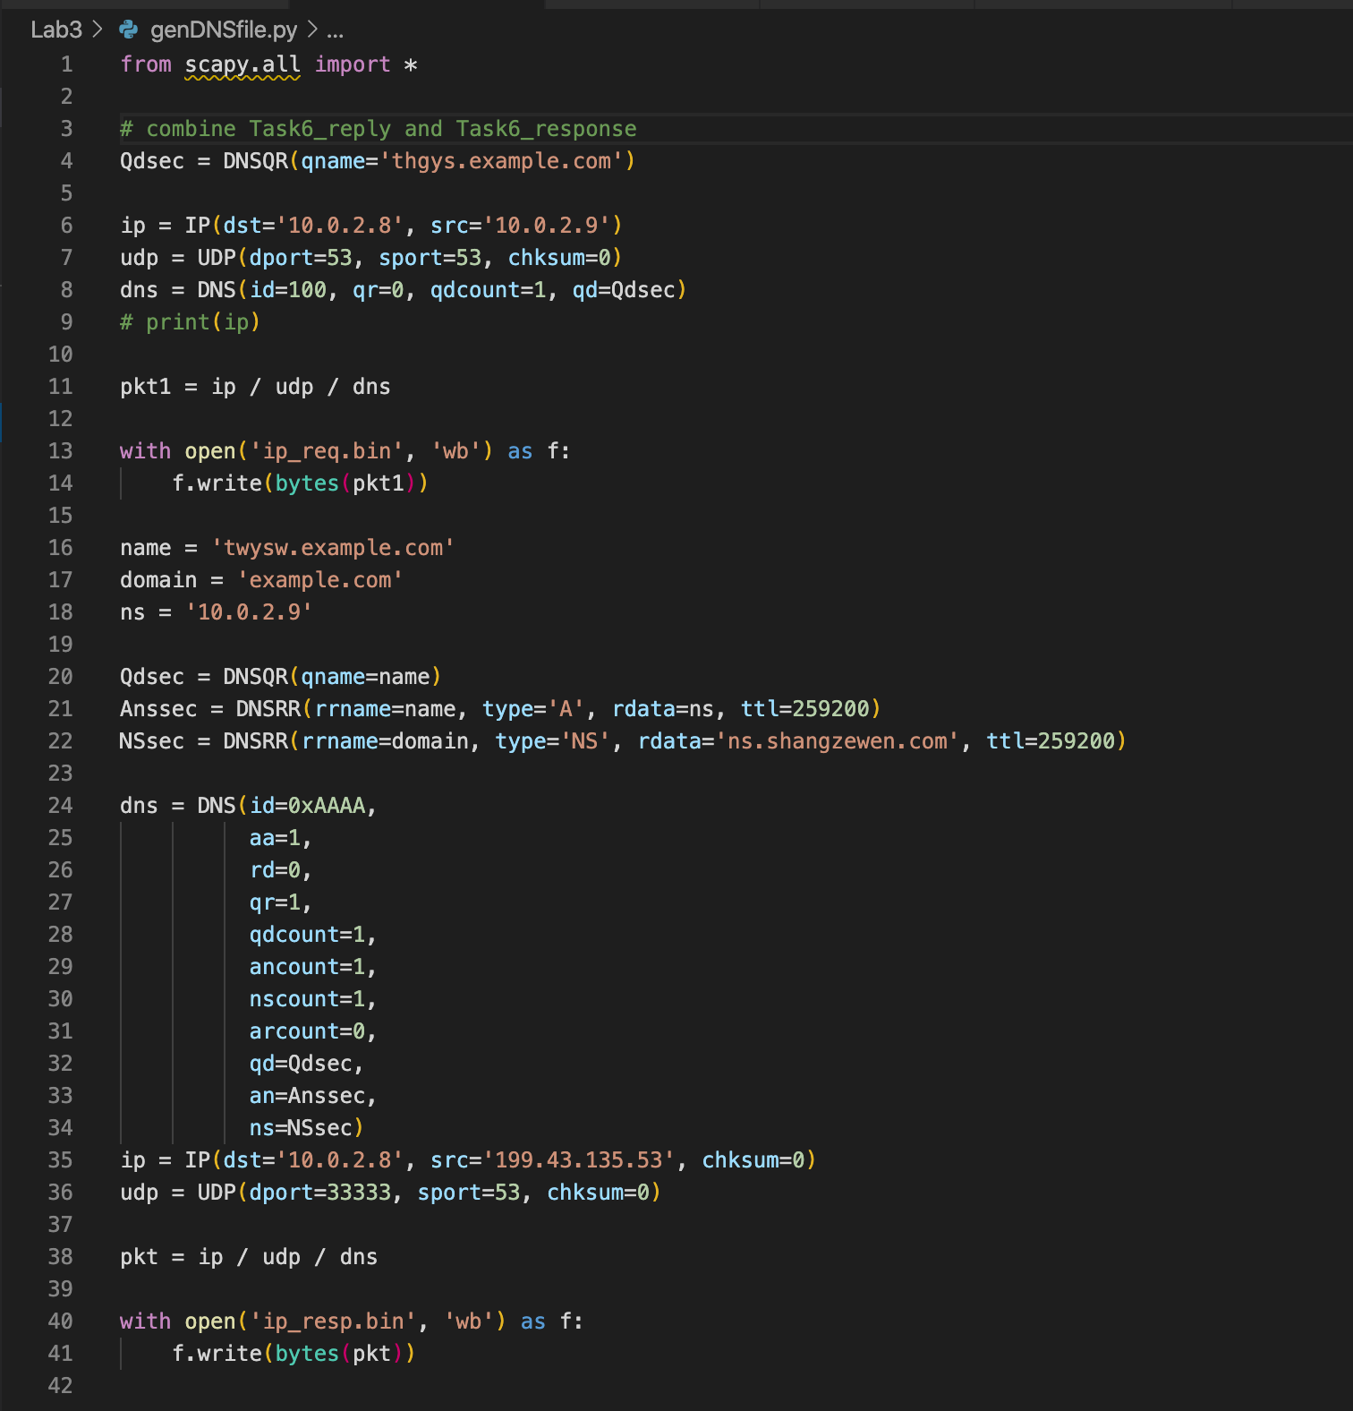

* Code for attack.c:

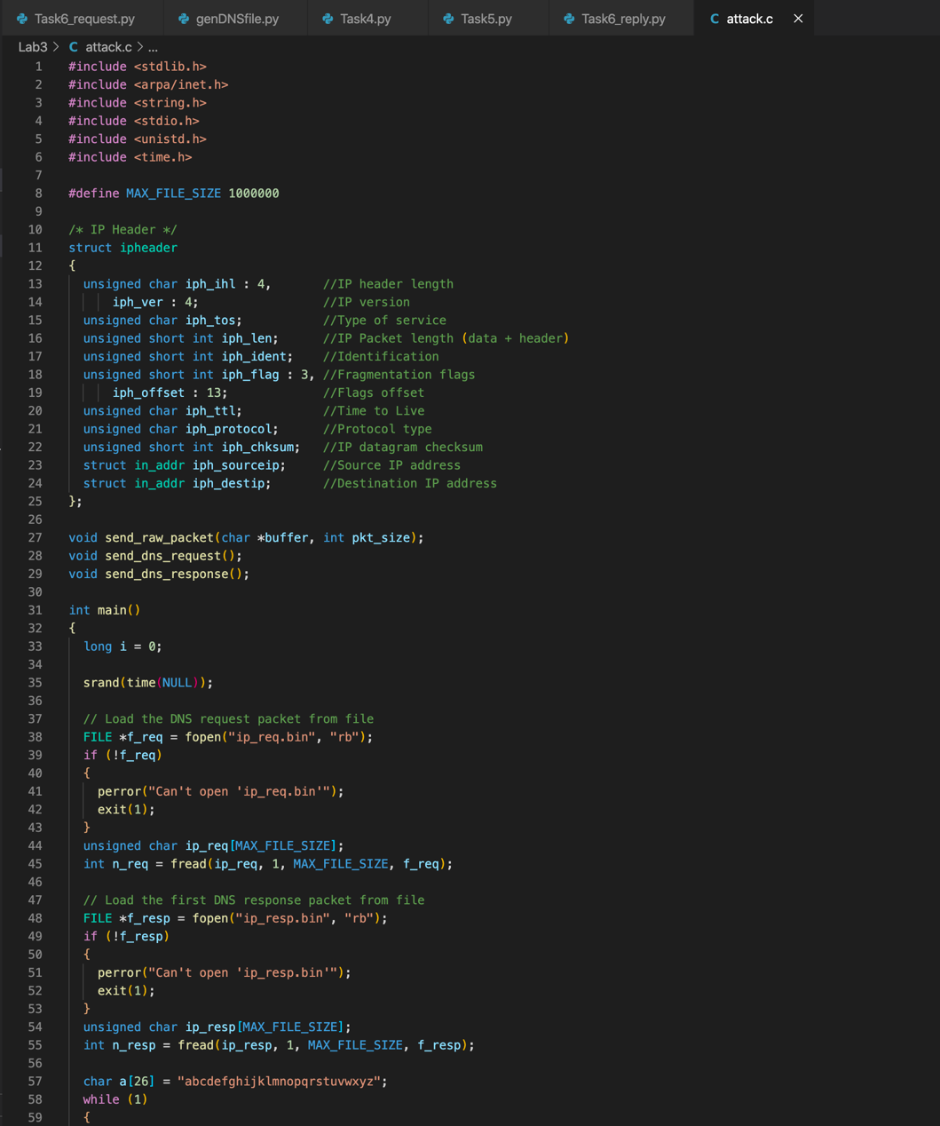

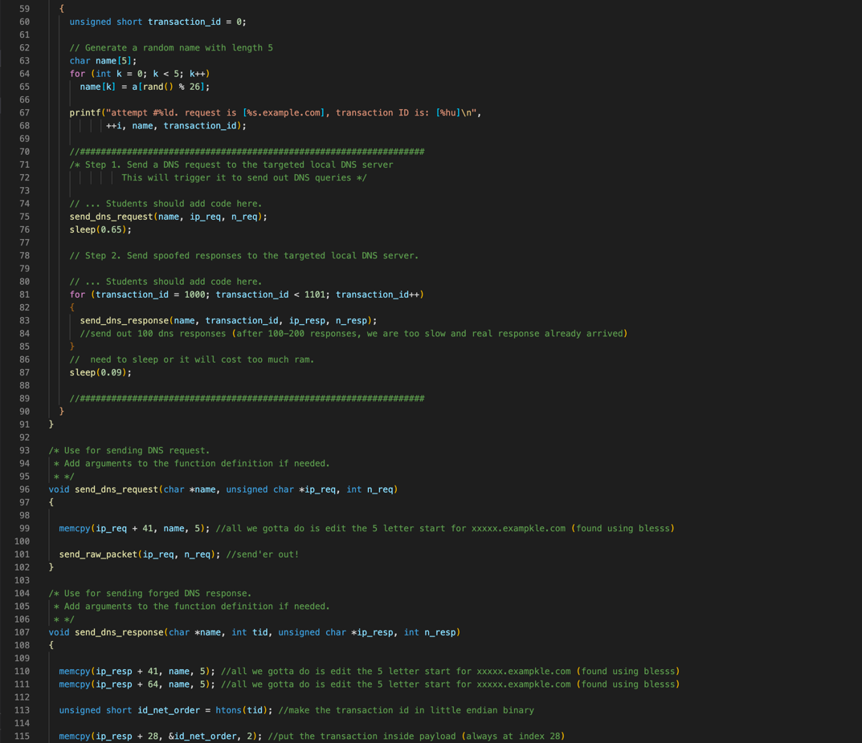

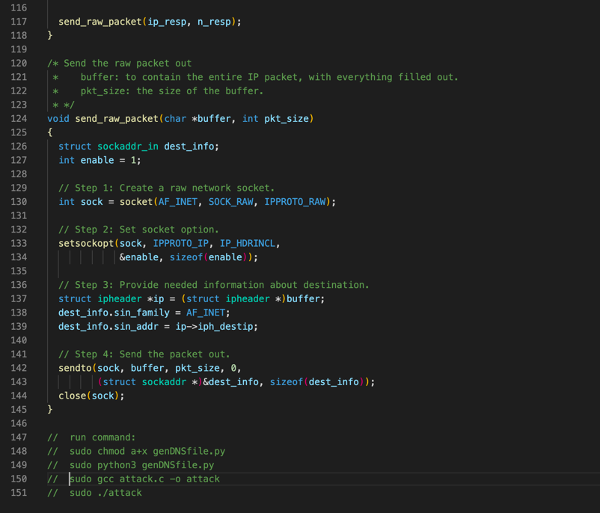

* I also modify the example.com.zone file’s ns entry to the attacker’s domain which is ‘ns.shangzewen.com’ and include a shangzewen.com.zone file.

Example.com.zone:

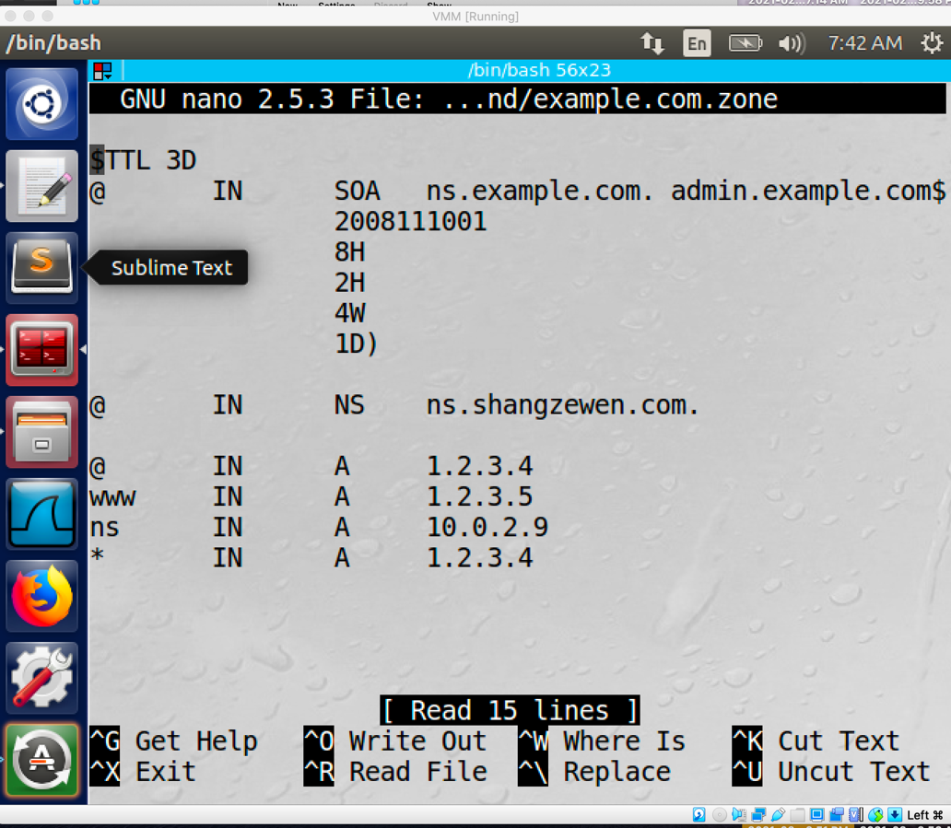

shangzewen.com.zone:

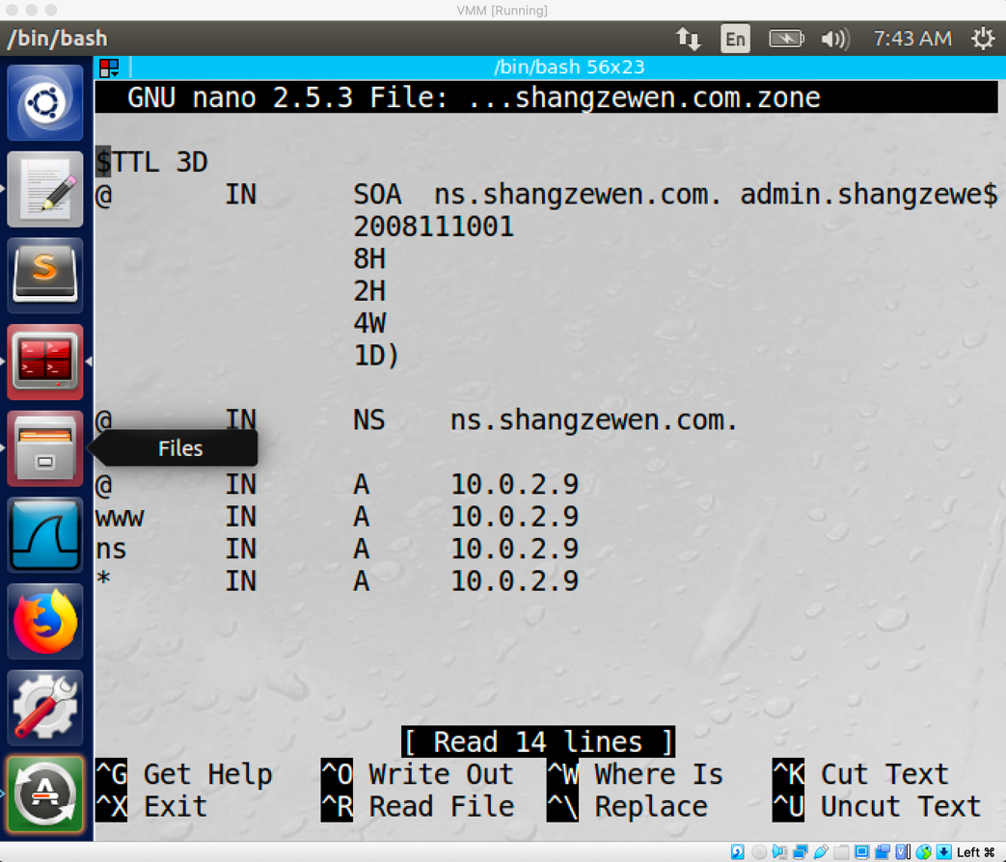

* In order to do the attack, I run the genDNSfile.py first by using ‘sudo python3 genDNSfile.py’ then I compile the attack.c file by using command ‘sudo gcc attack.c -o attack’. After compiled the file, I set up the attack by using command ‘sudo ./attack’. After a while, by checking the DNS cache on the local DNS server machine, I am able to find the cache of the ‘ns.shangzewen.com’ entry by using command ‘cat /var/cache/bind/dump.db | grep shangzewen.
* Result:

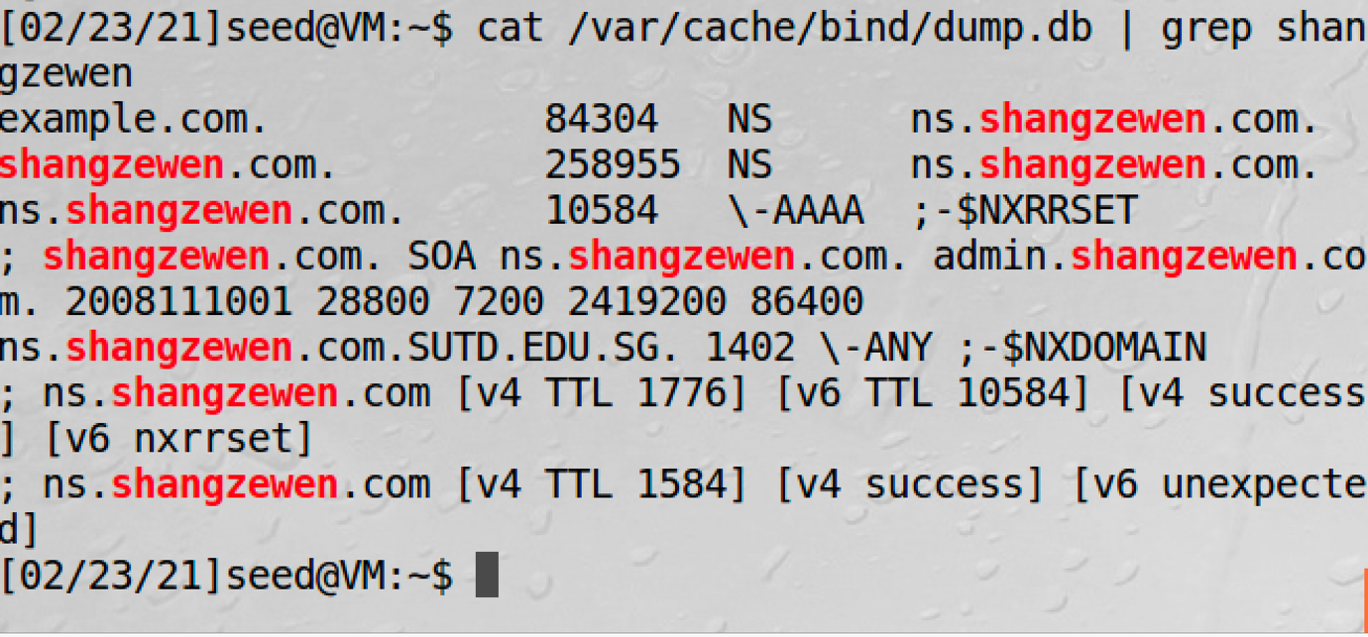

Task7:

* When I run command ‘dig [www.example.com](http://www.example.com)’ and the command ‘dig @ns.shangzewen.com’ the result will show example.com nameserver will match the ‘ns.shangzewen.com’ which is the attacker’s IP address. Which means the attack is succeed.